**School of Electrical and Electronic Engineering**



Embedded Systems Project

DESIGN REPORT #1

Title: ?

Group Number: ?

|  |  |  |
| --- | --- | --- |
| Group members name: | ID Number | I confirm that this is the group’s own work. |
|  |  |  |
|  |  |  |
|  |  |  |
|  |  |  |
|  |  |  |

Tutor: Click here to enter text.

Date: Click here to enter a date.

Contents

1. Introduction 1

2. Motor characterisation 1

3. Load measurements 1

4. Gear ratio selection 1

5. Summary 1

6. References 1

# Introduction

* See the chapter on Reports (near the start of the ESP Procedures Handbook).
* See the specific marking scheme for this section of the report.

You may want to reference books and papers that you have researched. Give their reference like this [1] (see the References section at the end of this document).

# Motor characterisation

* See the chapter on Reports (near the start of the ESP Procedures Handbook).
* See the specific marking scheme for this section of the report.

# Load measurements

* See the chapter on Reports (near the start of the ESP Procedures Handbook).
* See the specific marking scheme for this section of the report.

# Gear ratio selection

A primary aim of the project is to allow the buggy move at the highest possible speed and simultaneously move up the highest incline available. As both speed and torque are inversely proportional, a mechanism is needed to balance this relationship in the most effective way. This mechanism is applied using a gearbox in which a connection is achieved between the electric motors and the buggy wheels. This linkage allows the output shaft operate at a lower speed than the input shaft. This compensation gives a mechanical benefit in terms of an increased torque at the output shaft.

To illustrate the importance of the gearbox, an assumption is made that the given motors will solely drive the buggy, with no gearbox. As stated in section 3, the required wheel torque to go up the maximum incline is ${ T}_{3}= 0.0786 Nm$. From the Torque-Current relationship in Figure ???, the torque could be inserted in the equation:

$T=0.008I-0.0009 (4.1)$ giving a calculated current of $I=\frac{0.0786 + 0.0009}{0.008}=9.9375 A$.

Now, using the Voltage-Current relationship in Figure ???, the required motor voltage:

$$V=2.4211×9.9375+0.1568=24.216 V (4.2)$$

These values reveal the required current and voltage to move the buggy up the ramp using just the motors, which explains the necessity of the gearbox which certainly reduces these current/voltage values into much convenient numbers.

**Required gear ratio**

Referring to Figure ???, the maximum available torque produced by the motor is T = 0.01 Nm at constant motor voltage of V = 5 V. This value is available at the maximum permissible current of 1.4 A. However, to avoid any risks, a safety margin is taken to assume no operation occurs at 1.4 A. Instead, the available motor torque is assumed to be at 1.12 A and so by reading the graph in Figure ???, this gives a motor torque of $T_{1}=0.008 Nm$. As before, required wheel torque is ${ T}_{3}= 0.0786 Nm$. As a result, the gear ratio formula could be used: $Ratio= \frac{T_{3}}{T_{1}} (4.3)$. Using (4.3), the required gear ratio is $Ratio= \frac{0.0786}{0.008}=9.825$.

**Chosen gearbox**

The design of the available gearboxes compromises of two gear stages, each with an efficiency of 85% giving an overall estimated efficiency of $η={0.85}^{2}=0.7725.$ Four gear wheels form the whole system including gear wheel 1 on the input shaft, gear wheels 2A and 2B both on the common shaft and gear wheel 3 on the output shaft. Figure 4.1 illustrates this, accompanied with the gear ratio formula.

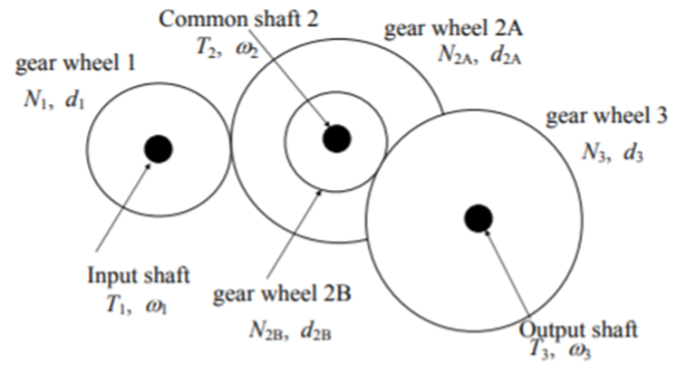

$$\frac{T_{3}}{T_{1}}= η\frac{N_{3}N_{2A}}{N_{2B}N_{1}} (4.4)$$

Figure 4.1 Common gear wheels on one shaft [1]

Table 4.1, shown below, compares the 3 different gearbox options available showing their respective calculated gear ratios, taking into account the efficiency.

Table 4.1 Gear ratio comparison

|  |  |  |  |  |  |
| --- | --- | --- | --- | --- | --- |
| Option no. | $$N_{1}$$ | $$N_{2A}$$ | $$N_{2B}$$ | $$N_{3}$$ | Gear ratio using (4.4) |
| 1 | 16 | 48 | 12 | 48 | $$0.7725×\frac{48×48}{12×16}= 9.27$$ |
| 2 | 16 | 50 | 10 | 48 | $$0.7725×\frac{48×50}{10×16}= 10.84$$ |
| 3 | 16 | 50 | 10 | 60 | $$0.7725×\frac{60×50}{10×16}= 13.55$$ |

Consequently, gearbox 2 is the chosen option due its gear ratio providing the best correspondence with the required gear ratio above (9.825).

**Intermediate shaft position**

To achieve the required intermediate shaft position, the Pitch Circle Diameter (PCD) needs to be calculated, using the following formula: $PCD=no. of teeth ×MOD \left(4.5\right).$ In this case all gears are 0.5 mm module. For gearbox 2, using (4.5), PCD(1) = 8 and PCD(2A) = 25.

Furthermore, the x-coordinate of the center of the intermediate shaft, with respect to gear wheel 1 center, is calculated using the formula

$x=\frac{PCD\left(1\right)+PCD\left(2A\right)}{2}+0.1 mm= \frac{8 + 25}{2}+0.1= 16.6 mm$

**Maximum speed**

From Figure ??? above, at 1.12 A, the motor speed is measured to be $ω_{1}= 2546 rpm.$ The maximum speed occurs during the rolling movement instead of the static. As a result, from Figure ???, the wheel torque during rolling at the flat is ${ T}_{3}=0.014 Nm$ and at the ramp is $T_{3}=0.0775 Nm.$

Using the following torque-speed relationship $ω_{3}= \frac{ω_{1}×T_{1}}{T_{3}} \left(4.6\right)$, the estimated maximum speed at the flat is $ω_{3}= \frac{2546 ×0.008}{0.014}=1454.9 rpm=0.762 m/s.$ Using (4.6) again, the estimated maximum speed at the ramp is $ω_{3}= \frac{2546 ×0.008}{0.0775}=262.8 rpm=0.138 m/s.$

# Summary

* Design recommendations
* Summary of key results and assumptions.

# References

1. See the section on Citations and Referencing Styles in the ESP Procedures Handbook.

Make sure that you have **read the top** of the marking scheme to look for report length etc.

Make sure that you have **read the bottom** of the marking scheme for Presentation and Penalties.

Remember to update your table of contents before submitting the report.

Aim to submit the report long before the deadline, to mitigate last minute problems with the internet and with Blackboard.